**Question 3: -**

1. **Provide a summary of the data that includes the number of cities and number of states**
2. Count of Cities
3. 13131
4. Count of States
5. 51
6. Count of Metros
7. 702
8. Count of Counties
9. 1227
10. State wise Mean of Rent dataset
11. State
12. AK    1565.525822
13. AL     986.670140
14. AR     909.950746
15. AZ    1199.469692
16. CA    2106.475654
17. CO    1540.457862
18. CT    1767.577829
19. DC    2429.413333
20. DE    1305.799649
21. FL    1503.682127
22. GA    1114.088731
23. HI    1954.977778
24. IA    1085.887252
25. ID     980.662137
26. IL    1458.476681
27. IN     989.533885
28. KS    1039.735976
29. KY    1102.186458
30. LA    1215.655032
31. MA    1870.123087
32. MD    1784.494052
33. ME    1181.627411
34. MI    1065.243846
35. MN    1346.172821
36. MO    1083.175578
37. MS    1026.907249
38. MT    1091.196793
39. NC    1081.376864
40. ND    1210.023026
41. NE    1111.696512
42. NH    1489.666358
43. NJ    2034.977271
44. NM    1143.519285
45. NV    1216.269495
46. NY    1743.535364
47. OH    1080.421618
48. OK     888.233354
49. OR    1255.147801
50. PA    1273.027485
51. RI    1579.111515
52. SC    1111.197346
53. SD    1156.297030
54. TN    1109.920118
55. TX    1382.950652
56. UT    1340.916843
57. VA    1392.020041
58. VT    1403.754465
59. WA    1436.863551
60. WI    1183.897077
61. WV    1017.817140
62. WY    1140.778802
63. Name: value, dtype: float64
64. State Wise Mean of Price_Sqft dataset
65. State
66. AK    0.953242
67. AL    0.640920
68. AR    0.609629
69. AZ    0.732260
70. CA    1.312985
71. CO    1.003775
72. CT    1.092966
73. DC    2.061707
74. DE    0.828632
75. FL    1.011789
76. GA    0.675739
77. HI    1.607215
78. IA    0.813626
79. ID    0.650774
80. IL    1.000342
81. IN    0.670327
82. KS    0.733732
83. KY    0.722213
84. LA    0.778753
85. MA    1.157484
86. MD    1.105901
87. ME    0.924815
88. MI    0.772782
89. MN    1.002346
90. MO    0.784039
91. MS    0.647453
92. MT    0.852381
93. NC    0.707674
94. ND    0.979163
95. NE    0.810882
96. NH    0.910400
97. NJ    1.207681
98. NM    0.689832
99. NV    0.788204
100. NY    1.120839
101. OH    0.730217
102. OK    0.638857
103. OR    0.852318
104. PA    0.823628
105. RI    1.103743
106. SC    0.739601
107. SD    0.907630
108. TN    0.698086
109. TX    0.786354
110. UT    0.877708
111. VA    0.898246
112. VT    0.830588
113. WA    0.898432
114. WI    0.760106
115. WV    0.696613
116. WY    0.877799

Attached Code:-

**2. Determine average, minimum and maximum rent across the entire dataset**

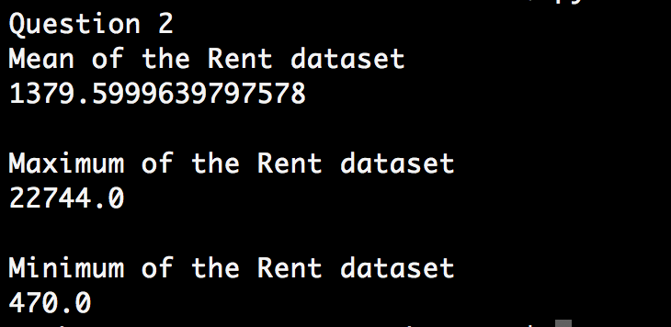

Attached Code: -

1. **Determine the average, minimum and maximum price per sq ft across the entire dataset**

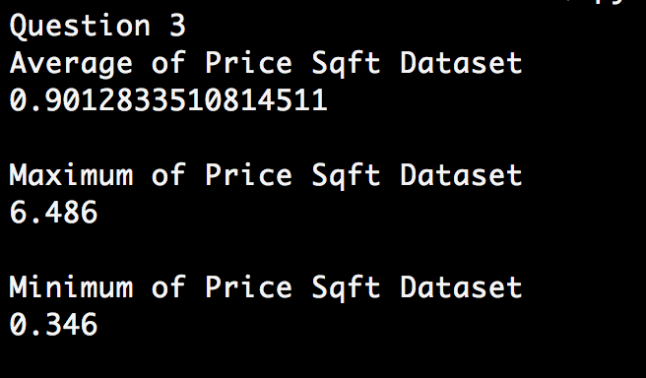

1. **What is the average price per sq ft in NY state?**

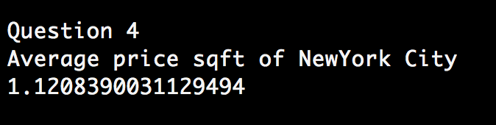

1. **How many metros have price per sq ft greater than the above average?**

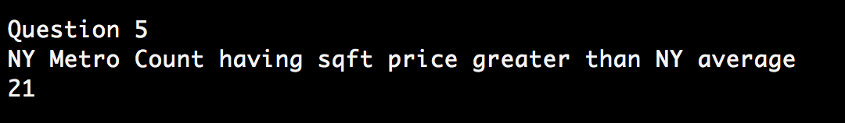

1. **What are the names of the metros and the cities they are in?**

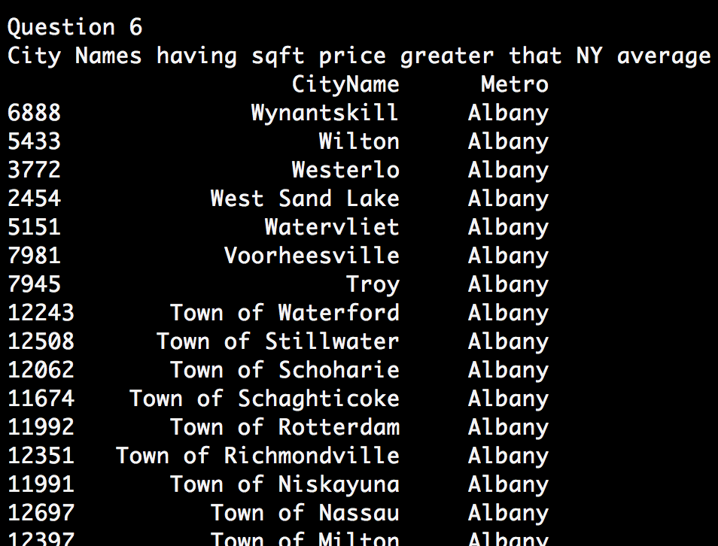

** NOTES: - There are total of 663 rows for this result set i.e., there are total 663 cities having sqft price greater that the New York sqft price average.

1. **Which metro(s) in the state had the highest increase in price per sqft between September 2015 and September 2016?**

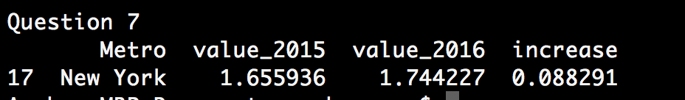

** Assumption: - We have shown the output for the Metro in NewYork state which had the highest increase per sqft between Sep 2015 and Sep2016

Attached code - 